1. Create a spinning cube for each town
2. Attach the Town Name to it

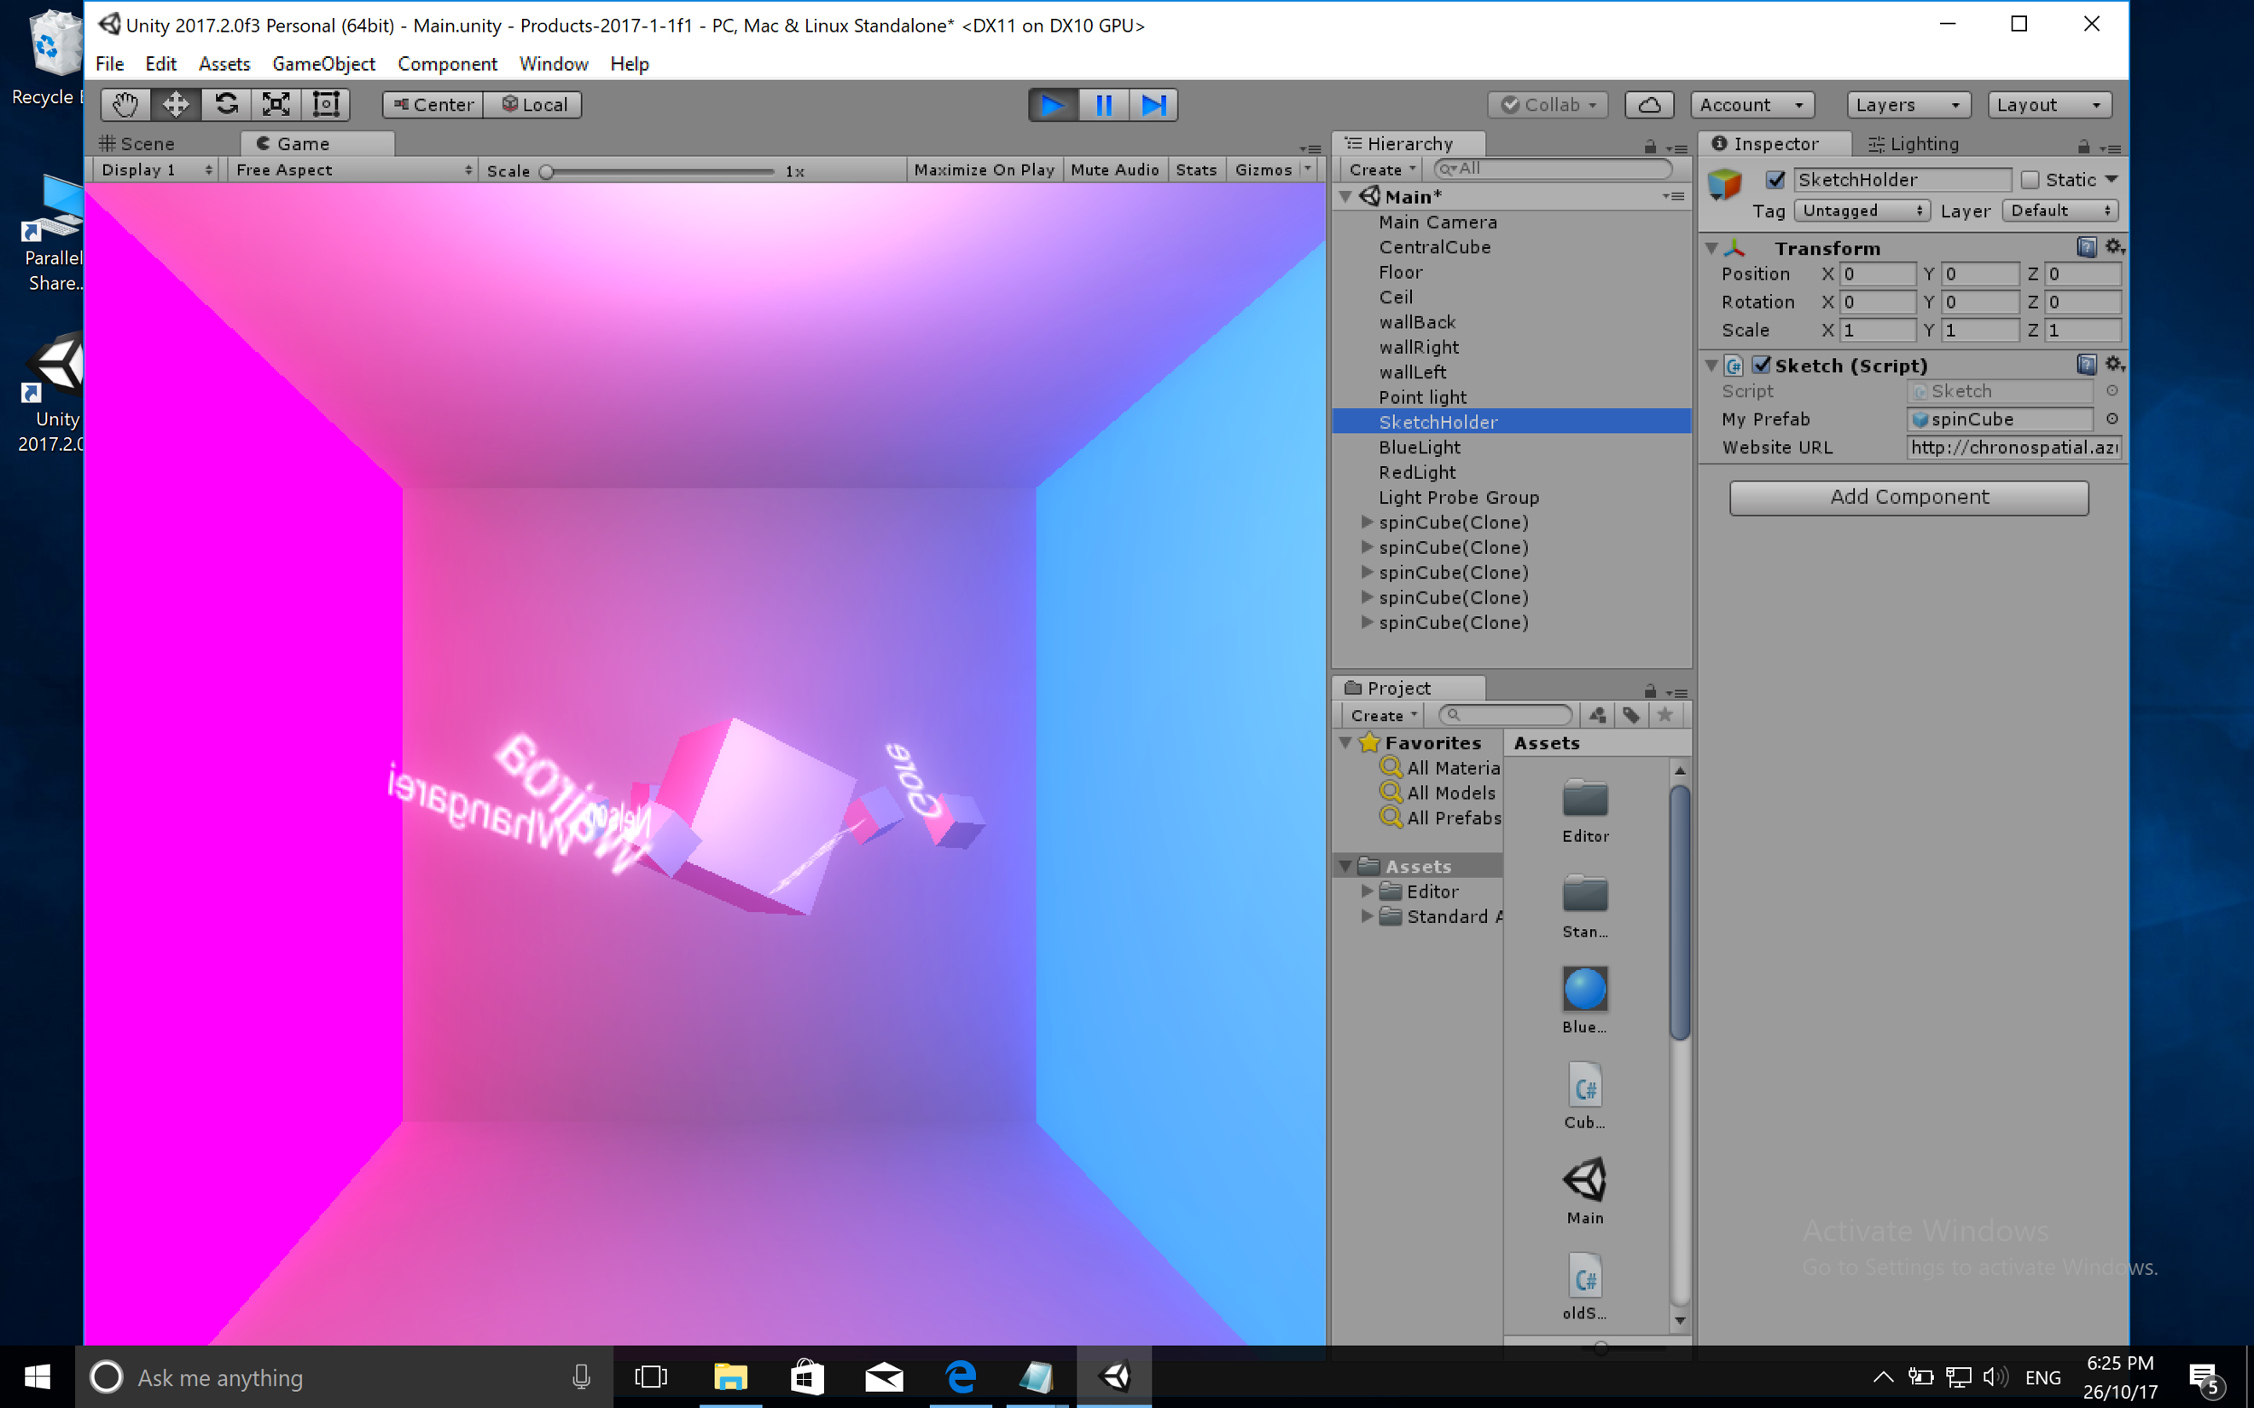

1. Place Cubes at their Latitude, Altitude, Longitude coordinates

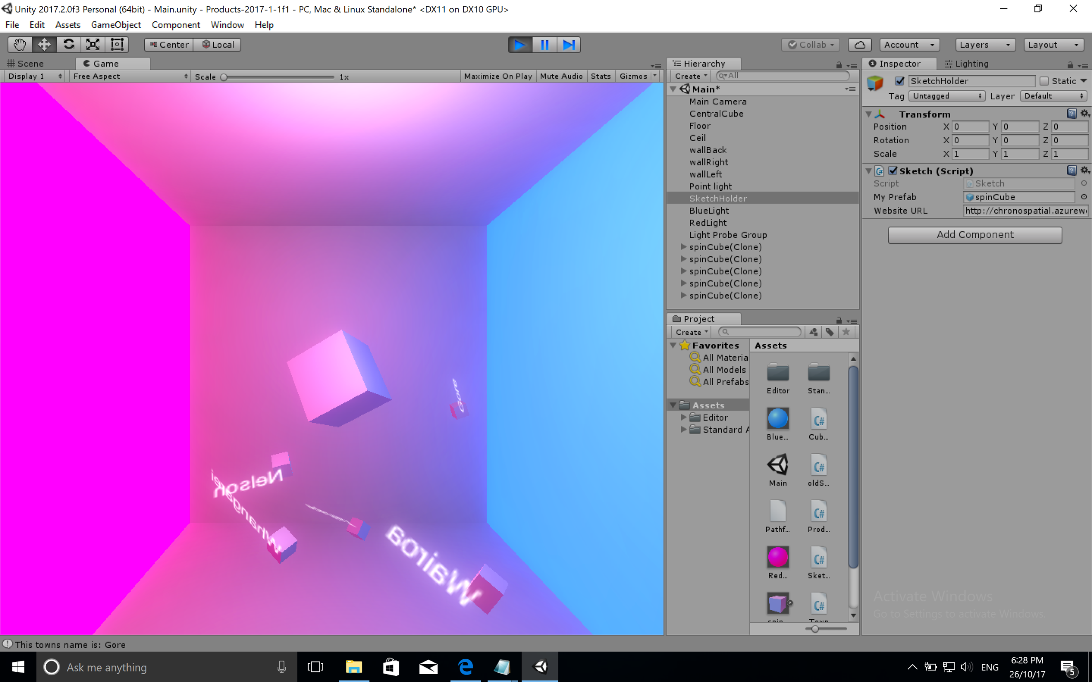

1. Stop them spinning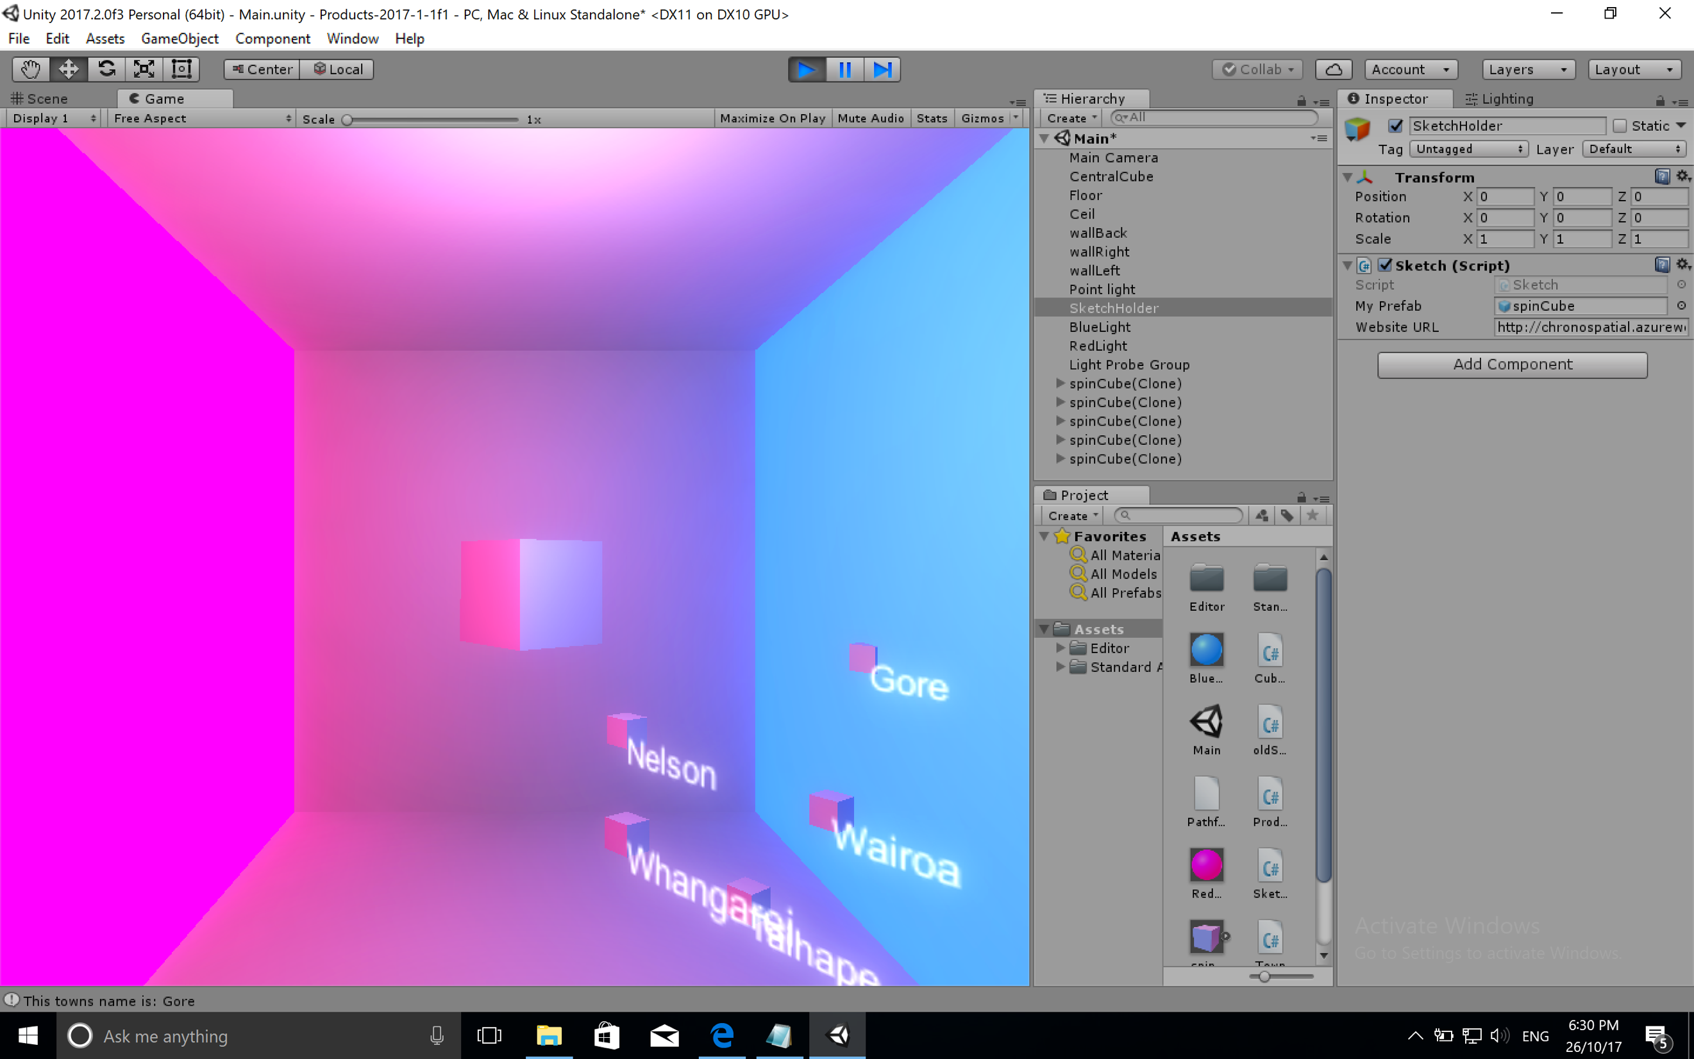

(The cubes have each individually stopped spinning and now rotate around the CentralCube.)

Set the size of each cube

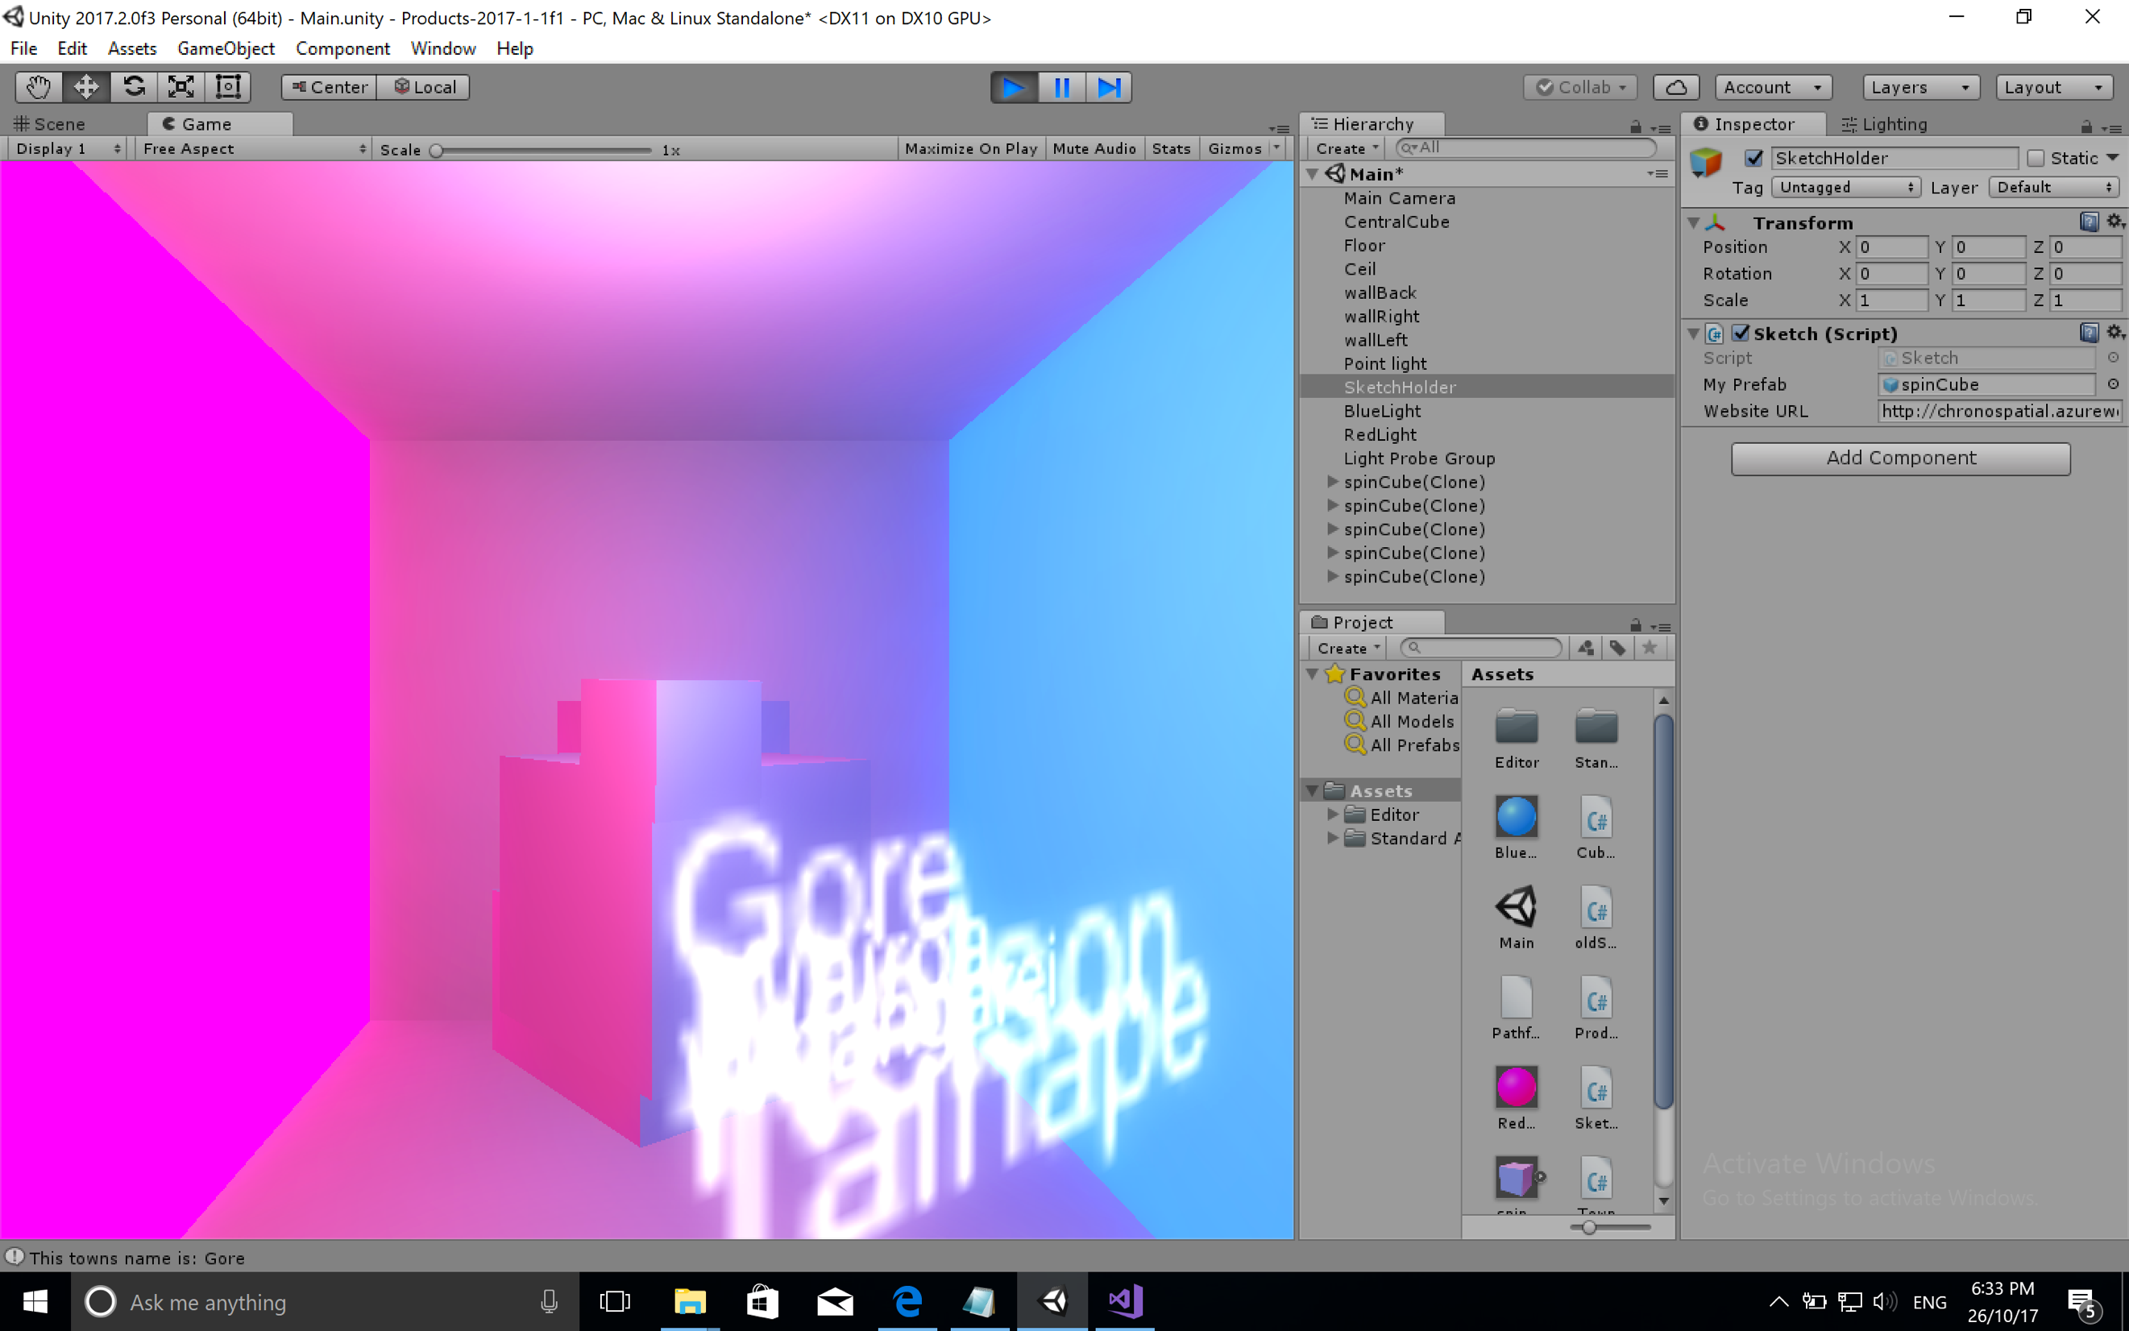

Set Prefab based on “Symbol” value

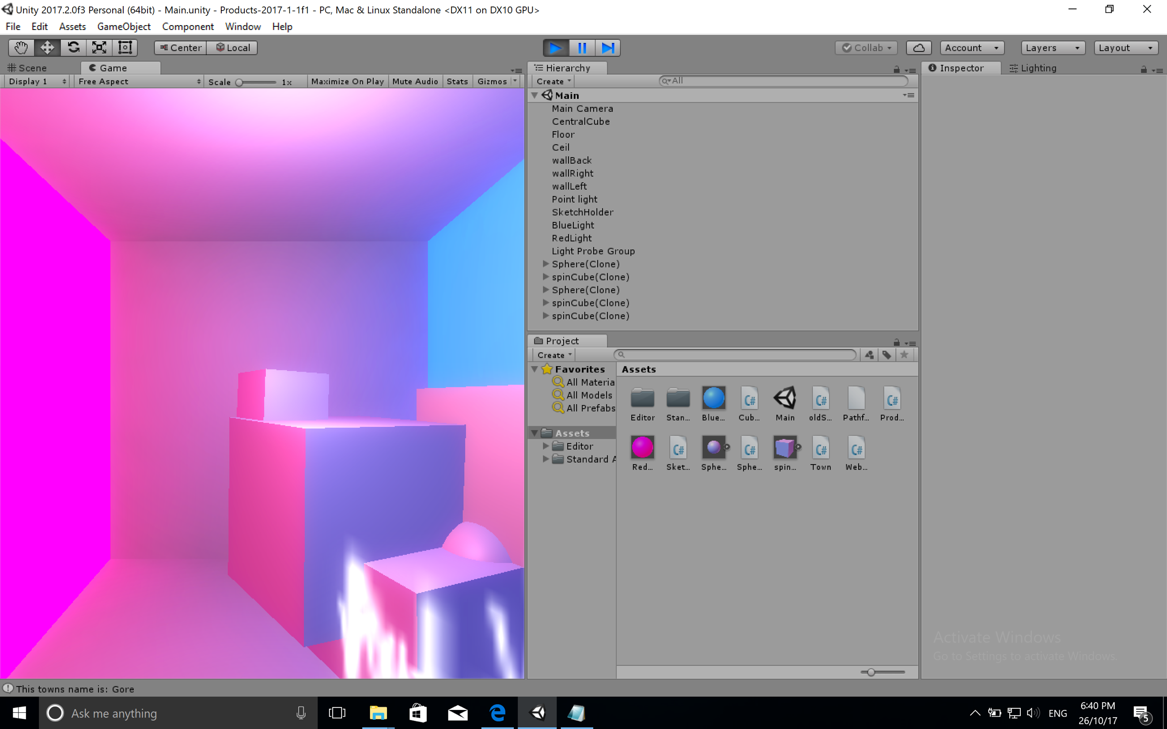

1. Set a breakpoint and examine values in array of Towns

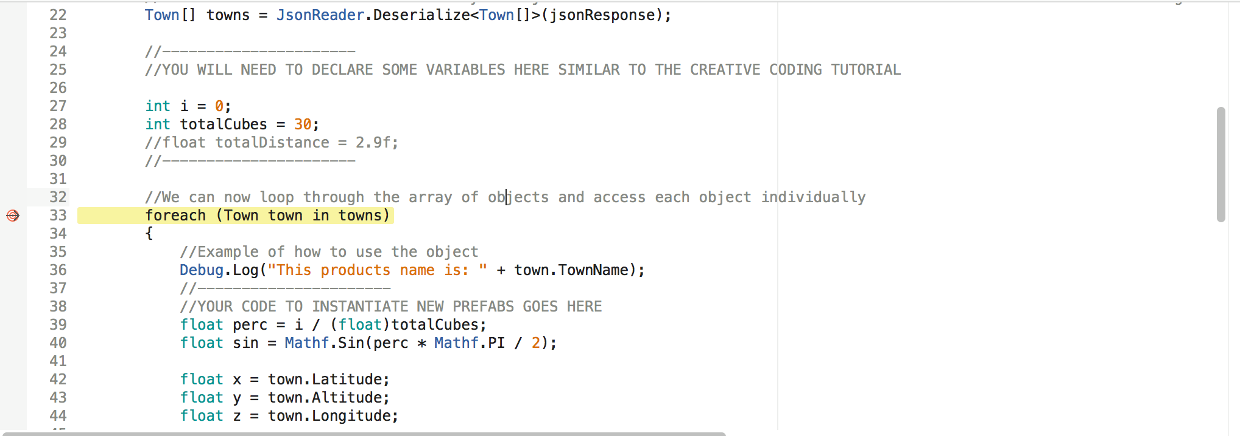

I chose to use Line 33’s foreach look to 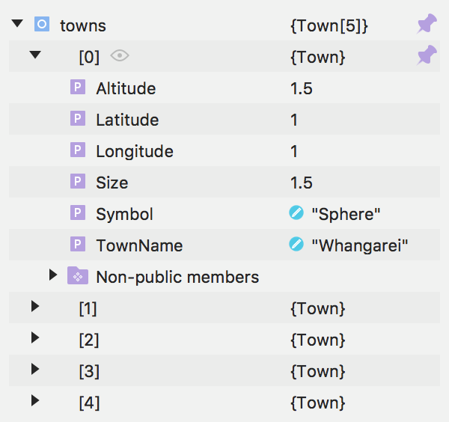examine the values in the Towns array

1. Make spheres a different colour to cubes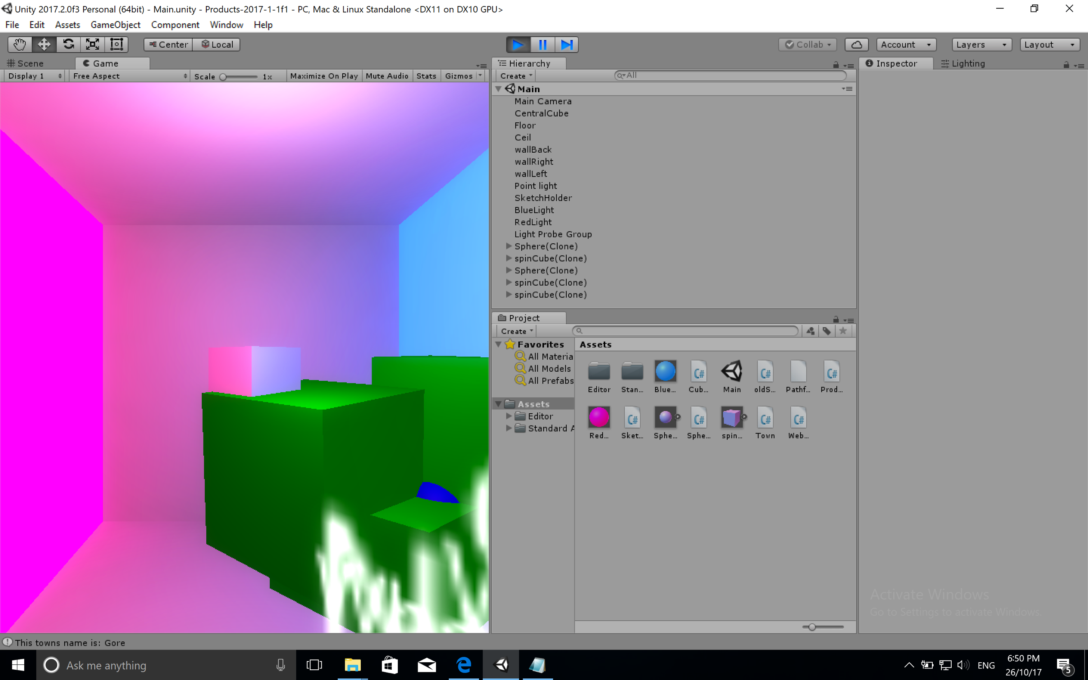

Link to GitHub:

<https://github.com/Infosys320/labtest2>